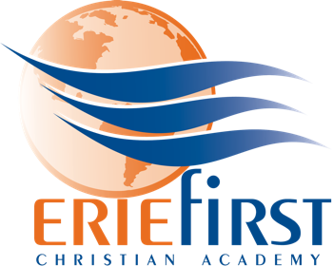

Athletic Assistant / Game Day Manager
Job Description

Erie First Christian Academy (EFCA) is seeking a part-time Athletic Assistant / Game Day Manager for the upcoming 2022/2023 season. This position would assist the Athletic Director in a variety of roles in the athletic department including home game-day management, uniform and equipment inventory, and marketing / social media. EFCA currently has two PIAA sports (Women’s Volleyball and Men’s Basketball) and 5 sports in the New Penn Christian Conference (Middle School Women’s Volleyball, Men’s Soccer, Middle School Boys & Girls Basketball, Women’s Soccer). We also have co-ops for Football and Men’s Volleyball.

Overview: It is the desire of EFCA Athletics to be a highly visible platform for the exhibition of Christian character. Our teams play to win, but more importantly to glorify God. We are committed to an environment of encouragement, teamwork, and excellence; not criticism, individualism, or perfectionism.

Contracted by: Administrator

Responsible to: Athletic Director

Supervises: Game day preparations

Evaluation: Performance will be evaluated by the Athletic Director in accordance with provision in this job description.

Essential Job Functions:

→ Assist with set-up, game/match management and clean up of home athletic events
→ Greet visiting coaches/teams and provide accommodations as appropriate
→ Greet officials and provide accommodations as appropriate
→ Assist with video / photography for EFCA digital media
→ Assist with inventory management of both uniforms and equipment
→ Other duties as assigned by the Athletic Director

Requirements / Education / Experience:

→ Successful candidate must possess a high school diploma or GED equivalent
→ Candidate must have a valid driver’s license
→ Candidate must be able to supply transportation
→ Prior coaching, athletics or teaching experience preferred but not required
→ Child clearances must be completed before starting employment
→ Must be flexible and able to work evenings and occasional Saturdays

